DS.140 Integration Design Specification



Item Planning load demand Integration

SCM_RICE_318

Author: Pranjul Garg

Creation Date: May 20, 2022

Last Updated: May 20, 2022

Version: 1.0

**Approvals:**

|  |  |
| --- | --- |
| <Approver 1> | <Rakesh Khanna / Naushad / Amit> |
| <Approver 2> | <Business Owner> |

# Document Control

## Change Record

| Date | Author | Version | Change Reference |
| --- | --- | --- | --- |
| 20-May-2022 | Pranjul Garg | 1.0 | No Previous Document |
|  |  |  |  |
|  |  |  |  |
|  |  |  |  |

2

## Reviewers

| Name | Position |
| --- | --- |
| FHL Business | Business User |
| FHL IT Group | Fortis IT Team |
|  |  |
|  |  |

Contents

1 Document Control ii

1.1 Change Record ii

1.2 Reviewers ii

2 Introduction 4

2.1.1 Scope for this Document 4

2.1.2 Intended Audience 4

3 Overview 5

3.1 Business Objectives 5

3.2 Major Features 5

3.3 Glossary 5

4 High-Level Fusion Integration flow 6

5 Technical Design Details 7

5.1 OIC Services 7

5.2 Oracle PaaS DBCS components 8

5.3 Technical flow 8

6 Data FIELD Mapping 23

6.1 File format 23

6.2 Frequency 23

7 Exception handling 24

7.1 Scenarios 24

8 Assumptions / Considerations 25

9 Open and Closed Issues 26

9.1 Open Issues 26

9.2 Closed Issues 26

# Introduction

### Scope for this Document

This analysis specification document is prepared to layout the design for an integration to load the planning demand in Fusion application based on the transactions of the last 56 days.

### Intended Audience

This document is intended for the following groups to provide the action items and consideration that are required to complete the implementation of the various Supply Chain and Finance related functionalities from Oracle Fusion.

#### Fortis Business Users

This document will be helpful for Fortis Business users to understand the technical design and process change with the new structure implemented in Oracle. The business user will validate this document after the verification of the requirement.

#### PwC Technical Team

The PwC technical team will use this document as a source technical design document to develop the technical solution to implement / deploy in Oracle Fusion.

#### Fortis IT Team

The Fortis IT Team must facilitate the PwC technical team for requisite details and other elements required from Business. The Fortis IT team is also responsible to arrange and provide required technical information wherever is required.

# Overview

Fortis Healthcare Limited (FHL) is a chain of hospitals, headquartered in India. Fortis started its health care operations from Mohali where first Fortis hospital was started. Later, the hospital chain purchased the healthcare branch of the Escorts group and increased its strength in various parts of the country. The Fortis health care also operates its hospital in Vasant Kunj, Faridabad, Gurgaon. The FMRI hospital at Gurgaon is the headquarter of Fortis healthcare with all the major facilities at the hospital.

This specification document is prepared to layout the design for an integration to load the planning demand in Fusion application based on the transactions of the last 56 days.

## Business Objectives

The following are the business objectives.

1. To have a secure, reliable, and scalable design flow to extract and load the planning demand data.
2. To have a solution providing the monitoring capabilities.

## Major Features

The proposed solution will have the following features involved:

1. OIC integration invokes Fusion ESS job (BI report) to fetch the eligible planning demand data in the FBDI format.
2. The OIC integration then invokes the seeded ESS job: Load Interface File for Import to upload this data in Fusion application.

## Glossary

REST

Representational State Transfer.

OIC

Oracle Integration Cloud

ESS

Enterprise Scheduler Service

# High-Level Fusion Integration flow

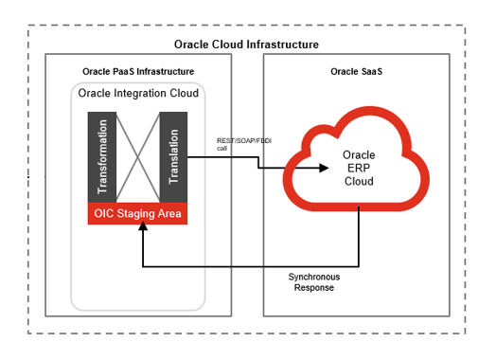

# Technical Design Details

This section describes the technical details of all the components involved in the design for an integration to load the planning demand in Fusion.

## OIC Services

A scheduled orchestration has been designed in OIC to load the planning demand in the system:

|  |  |
| --- | --- |
| **OIC Integration Name** | Fortis Item Planning Demand Load Integration |
| **OIC REST Endpoint URL** | [NA](https://oic-prod-nr5lr39yailj-bo.integration.ocp.oraclecloud.com:443/ic/api/integration/v1/flows/rest/FORTI_TRIGG_AUTO_PR_CANCEL_INTG/1.0/prCancellation/) |
| **Method** | NA |
| **Frequency** | Daily, 11 PM IST |

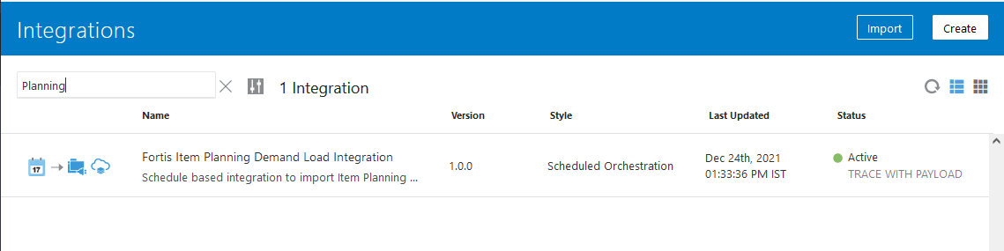

## Oracle PaaS DBCS components

This integration design does not use any DBCS related component.

## Technical flow

Following is the complete technical flow for this integration design:

1. The OIC integration invokes ESS Job: Fortis Item Org Demand Load Report (path: /oracle/apps/ess/custom/scm/inv) which internally invokes BI Report: Fortis Item Org Demand Load Report to fetch the eligible data as per 4 planners from the system.
2. This ESS job (or BI report) has the following input parameters:

|  |  |
| --- | --- |
| **Input parameter name** | **Details** |
| P_FTP_SERVER | The BI server alias name, where the report output needs to be bursted. |
| P_FTP_PATH | The SFTP server path of PaaS DBCS |
| P_FILE_NAME | The output file name of the report output |
| P_PLANNER_A | Possible values as Y/N. If this parameter is passed as ‘Y’, then transactions for Planner A will be fetched from the system. |
| P_PLANNER_B | Possible values as Y/N. If this parameter is passed as ‘Y’, then transactions for Planner B will be fetched from the system. |
| P_PLANNER_C | Possible values as Y/N. If this parameter is passed as ‘Y’, then transactions for Planner C will be fetched from the system. |
| P_PLANNER_D | Possible values as Y/N. If this parameter is passed as ‘Y’, then transactions for Planner D will be fetched from the system. |

1. The SFTP Server has been configured in BI Admin > Delivery Channel > FTP with the details of PaaS DBCS SFTP server. The server name: FORTIS_PAAS_SFTP is then used as an input parameter value in the above BI report.

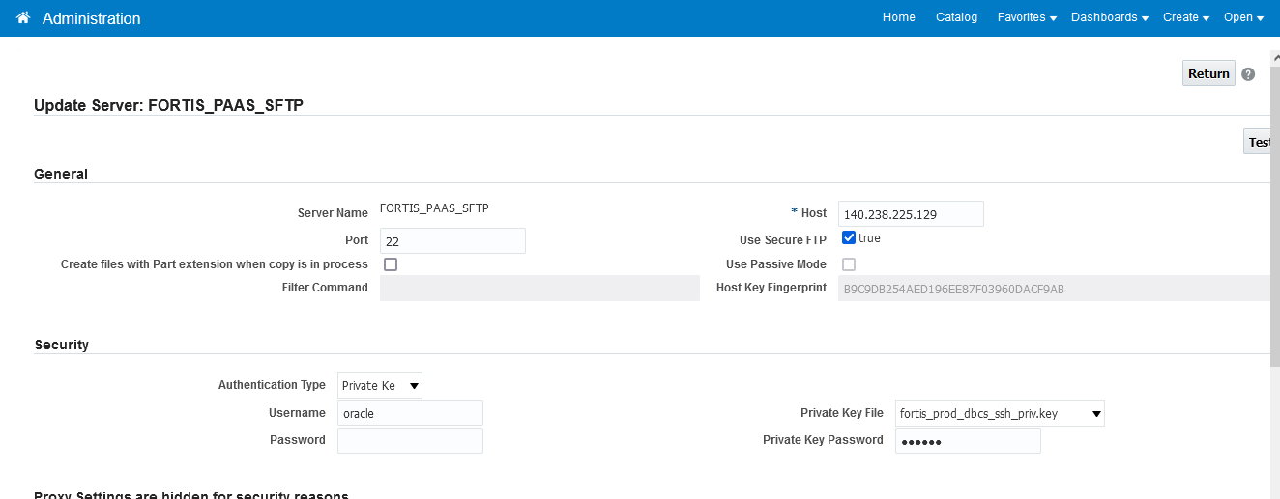

1. This BI report uses the following query to fetch the data. This query fetches the material transactions which have been created in IO (other than FMO) and for transaction type: (Department Consumption, Patient Consumption, OPD Pharmacy Consumption, Departmental Consumption – Adjustment, Patient Return) in the last 56 days.

SELECT * FROM (

SELECT 'OPS' AS KEY,

iop.organization_code organization_code,

1 forecast_prioprity,

egib.item_number item_name,

NULL demand_class,

1 bucket_type,

NULL forecast_mad,

mp.planner_code forecast_designator,

round(((ABS(SUM(imt.transaction_quantity))/56)*7)/6,0) using_requirement_quantity,

NULL using_assembly_item_name,

to_char(xx.date1,'yyyy/mm/dd') using_assembly_demand_date,

NULL AS customer_name,

NULL AS customer_site_code,

NULL AS forecast_mape,

NULL AS forecast_intermit_demand_flag,

NULL AS forecast_avg_interarrival_time,

NULL AS disable_date,

NULL AS sub_inventory_code,

NULL AS global_attribute_number11,

NULL AS global_attribute_number12,

NULL AS global_attribute_number13,

NULL AS global_attribute_number14,

NULL AS global_attribute_number15,

NULL AS global_attribute_number16,

NULL AS global_attribute_number17,

NULL AS global_attribute_number18,

NULL AS global_attribute_number19,

NULL AS global_attribute_number20,

NULL AS global_attribute_number21,

NULL AS global_attribute_number22,

NULL AS global_attribute_number23,

NULL AS global_attribute_number24,

NULL AS global_attribute_number25,

'END' END

FROM inv_material_txns imt,

egp_system_items_b egib,

inv_secondary_inventories isi,

inv_org_parameters iop ,

inv_txn_source_types_tl itst,

msc_planners mp,

inv_transaction_types_vl itt,

(SELECT A.date1

FROM (SELECT (TRUNC(sysdate)+70 - LEVEL) date1

FROM dual

WHERE 1=1 --TRIM(to_char((TRUNC(sysdate)+70 -LEVEL),'DAY')) != 7

CONNECT BY LEVEL <=70 ORDER BY 1) A

WHERE ROWNUM <=56) xx

WHERE imt.inventory_item_id = egib.inventory_item_id

AND imt.organization_id = iop.organization_id

AND imt.organization_id = egib.organization_id

AND imt.subinventory_code = isi.secondary_inventory_name

AND imt.organization_id = isi.organization_id

AND upper(isi.SECONDARY_INVENTORY_NAME) NOT LIKE '%RTV%'

AND imt.transaction_source_type_id = itst.transaction_source_type_id ( + )

AND egib.demand_period IS NOT NULL

AND egib.planner_code IS NOT NULL

AND egib.approval_status ='A'

AND egib.inventory_item_status_code = 'Active'

AND TRUNC(imt.transaction_date)>=(TRUNC(sysdate)- 56) --egib.demand_period)

AND mp.planner_code = egib.planner_code

AND itt.transaction_type_id = imt.transaction_type_id

AND nvl(:p_planner_a,'N') = 'Y'

AND mp.planner_code = 'Planner A'

AND EXISTS (SELECT 1

FROM fnd_lookup_values flv

where flv.lookup_type = 'INV_MATERIAL_PLANNING'

AND flv.lookup_code = egib.INVENTORY_PLANNING_CODE

AND upper(flv.meaning) = upper('Reorder point planning')

AND flv.enabled_flag = 'Y'

AND NVL(flv.end_date_active, SYSDATE+1) >= SYSDATE )

AND itt.transaction_type_name IN ('Department Consumption', 'Patient Consumption', 'OPD Pharmacy Consumption',

'Departmental Consumption - Adjustment', 'Patient Return')

AND iop.organization_code ! = 'FMO'

AND EXISTS (SELECT 1

FROM inv_organization_definitions_v iod

WHERE iod.organization_id = iop.organization_id

and (iod.ORGANIZATION_NAME like 'DTH%'

OR iod.ORGANIZATION_NAME like 'OP Pharmacy%'))

AND EXISTS (SELECT 1

FROM EGP_ITEM_CLASSES_B eicb

WHERE egib.item_catalog_group_id = eicb.item_class_id

AND eicb.ITEM_CLASS_CODE IN ('Pharmaceuticals', 'Medical_Consumables', 'EXTN_PH','EXTN_MC'))

GROUP BY egib.item_number,

iop.organization_code,

mp.planner_code,

xx.date1

UNION ALL

SELECT 'OPS' AS KEY,

iop.organization_code organization_code,

1 forecast_prioprity,

egib.item_number item_name,

NULL demand_class,

1 bucket_type,

NULL forecast_mad,

mp.planner_code forecast_designator,

round(((ABS(SUM(imt.transaction_quantity))/56)*7)/6,0) using_requirement_quantity,

NULL using_assembly_item_name,

to_char(xx.date1,'yyyy/mm/dd') using_assembly_demand_date,

NULL AS customer_name,

NULL AS customer_site_code,

NULL AS forecast_mape,

NULL AS forecast_intermit_demand_flag,

NULL AS forecast_avg_interarrival_time,

NULL AS disable_date,

NULL AS sub_inventory_code,

NULL AS global_attribute_number11,

NULL AS global_attribute_number12,

NULL AS global_attribute_number13,

NULL AS global_attribute_number14,

NULL AS global_attribute_number15,

NULL AS global_attribute_number16,

NULL AS global_attribute_number17,

NULL AS global_attribute_number18,

NULL AS global_attribute_number19,

NULL AS global_attribute_number20,

NULL AS global_attribute_number21,

NULL AS global_attribute_number22,

NULL AS global_attribute_number23,

NULL AS global_attribute_number24,

NULL AS global_attribute_number25,

'END' END

FROM inv_material_txns imt,

egp_system_items_b egib,

inv_secondary_inventories isi,

inv_org_parameters iop ,

inv_txn_source_types_tl itst,

msc_planners mp,

inv_transaction_types_vl itt,

(SELECT A.date1

FROM (SELECT (TRUNC(sysdate)+70 - LEVEL) date1

FROM dual

WHERE 1=1 --TRIM(to_char((TRUNC(sysdate)+70 -LEVEL),'DAY')) != 7

CONNECT BY LEVEL <=70 ORDER BY 1) A

WHERE ROWNUM <=56) xx

WHERE imt.inventory_item_id = egib.inventory_item_id

AND imt.organization_id = iop.organization_id

AND imt.organization_id = egib.organization_id

AND imt.subinventory_code = isi.secondary_inventory_name

AND imt.organization_id = isi.organization_id

AND upper(isi.SECONDARY_INVENTORY_NAME) NOT LIKE '%RTV%'

AND imt.transaction_source_type_id = itst.transaction_source_type_id ( + )

AND egib.demand_period IS NOT NULL

AND egib.planner_code IS NOT NULL

AND egib.approval_status ='A'

AND egib.inventory_item_status_code = 'Active'

AND TRUNC(imt.transaction_date)>=(TRUNC(sysdate)- 56) --egib.demand_period)

AND mp.planner_code = egib.planner_code

AND itt.transaction_type_id = imt.transaction_type_id

AND nvl(:p_planner_b,'N') = 'Y'

AND mp.planner_code = 'Planner B'

AND EXISTS (SELECT 1

FROM fnd_lookup_values flv

where flv.lookup_type = 'INV_MATERIAL_PLANNING'

AND flv.lookup_code = egib.INVENTORY_PLANNING_CODE

AND upper(flv.meaning) = upper('Reorder point planning')

AND flv.enabled_flag = 'Y'

AND NVL(flv.end_date_active, SYSDATE+1) >= SYSDATE )

AND itt.transaction_type_name IN ('Department Consumption', 'Patient Consumption', 'OPD Pharmacy Consumption',

'Departmental Consumption - Adjustment', 'Patient Return')

AND iop.organization_code ! = 'FMO'

AND EXISTS (SELECT 1

FROM inv_organization_definitions_v iod

WHERE iod.organization_id = iop.organization_id

and (iod.ORGANIZATION_NAME like 'DTH%'

OR iod.ORGANIZATION_NAME like 'OP Pharmacy%'))

AND EXISTS (SELECT 1

FROM EGP_ITEM_CLASSES_B eicb

WHERE egib.item_catalog_group_id = eicb.item_class_id

AND eicb.ITEM_CLASS_CODE IN ('Pharmaceuticals', 'Medical_Consumables', 'EXTN_PH','EXTN_MC'))

GROUP BY egib.item_number,

iop.organization_code,

mp.planner_code,

xx.date1

UNION ALL

SELECT 'OPS' AS KEY,

iop.organization_code organization_code,

1 forecast_prioprity,

egib.item_number item_name,

NULL demand_class,

1 bucket_type,

NULL forecast_mad,

mp.planner_code forecast_designator,

round(((ABS(SUM(imt.transaction_quantity))/56)*7)/6,0) using_requirement_quantity,

NULL using_assembly_item_name,

to_char(xx.date1,'yyyy/mm/dd') using_assembly_demand_date,

NULL AS customer_name,

NULL AS customer_site_code,

NULL AS forecast_mape,

NULL AS forecast_intermit_demand_flag,

NULL AS forecast_avg_interarrival_time,

NULL AS disable_date,

NULL AS sub_inventory_code,

NULL AS global_attribute_number11,

NULL AS global_attribute_number12,

NULL AS global_attribute_number13,

NULL AS global_attribute_number14,

NULL AS global_attribute_number15,

NULL AS global_attribute_number16,

NULL AS global_attribute_number17,

NULL AS global_attribute_number18,

NULL AS global_attribute_number19,

NULL AS global_attribute_number20,

NULL AS global_attribute_number21,

NULL AS global_attribute_number22,

NULL AS global_attribute_number23,

NULL AS global_attribute_number24,

NULL AS global_attribute_number25,

'END' END

FROM inv_material_txns imt,

egp_system_items_b egib,

inv_secondary_inventories isi,

inv_org_parameters iop ,

inv_txn_source_types_tl itst,

msc_planners mp,

inv_transaction_types_vl itt,

(SELECT A.date1

FROM (SELECT (TRUNC(sysdate)+70 - LEVEL) date1

FROM dual

WHERE 1=1 --TRIM(to_char((TRUNC(sysdate)+70 -LEVEL),'DAY')) != 7

CONNECT BY LEVEL <=70 ORDER BY 1) A

WHERE ROWNUM <=56) xx

WHERE imt.inventory_item_id = egib.inventory_item_id

AND imt.organization_id = iop.organization_id

AND imt.organization_id = egib.organization_id

AND imt.subinventory_code = isi.secondary_inventory_name

AND imt.organization_id = isi.organization_id

AND upper(isi.SECONDARY_INVENTORY_NAME) NOT LIKE '%RTV%'

AND imt.transaction_source_type_id = itst.transaction_source_type_id ( + )

AND egib.demand_period IS NOT NULL

AND egib.planner_code IS NOT NULL

AND egib.approval_status ='A'

AND egib.inventory_item_status_code = 'Active'

AND TRUNC(imt.transaction_date)>=(TRUNC(sysdate)- 56) --egib.demand_period)

AND mp.planner_code = egib.planner_code

AND itt.transaction_type_id = imt.transaction_type_id

AND nvl(:p_planner_c,'N') = 'Y'

AND mp.planner_code = 'Planner C'

AND EXISTS (SELECT 1

FROM fnd_lookup_values flv

where flv.lookup_type = 'INV_MATERIAL_PLANNING'

AND flv.lookup_code = egib.INVENTORY_PLANNING_CODE

AND upper(flv.meaning) = upper('Reorder point planning')

AND flv.enabled_flag = 'Y'

AND NVL(flv.end_date_active, SYSDATE+1) >= SYSDATE )

AND itt.transaction_type_name IN ('Department Consumption', 'Patient Consumption', 'OPD Pharmacy Consumption',

'Departmental Consumption - Adjustment', 'Patient Return')

AND iop.organization_code ! = 'FMO'

AND EXISTS (SELECT 1

FROM inv_organization_definitions_v iod

WHERE iod.organization_id = iop.organization_id

and (iod.ORGANIZATION_NAME like 'DTH%'

OR iod.ORGANIZATION_NAME like 'OP Pharmacy%'))

AND EXISTS (SELECT 1

FROM EGP_ITEM_CLASSES_B eicb

WHERE egib.item_catalog_group_id = eicb.item_class_id

AND eicb.ITEM_CLASS_CODE IN ('Pharmaceuticals', 'Medical_Consumables', 'EXTN_PH','EXTN_MC'))

GROUP BY egib.item_number,

iop.organization_code,

mp.planner_code,

xx.date1

UNION ALL

SELECT 'OPS' AS KEY,

iop.organization_code organization_code,

1 forecast_prioprity,

egib.item_number item_name,

NULL demand_class,

1 bucket_type,

NULL forecast_mad,

mp.planner_code forecast_designator,

round(((ABS(SUM(imt.transaction_quantity))/56)*7)/6,0) using_requirement_quantity,

NULL using_assembly_item_name,

to_char(xx.date1,'yyyy/mm/dd') using_assembly_demand_date,

NULL AS customer_name,

NULL AS customer_site_code,

NULL AS forecast_mape,

NULL AS forecast_intermit_demand_flag,

NULL AS forecast_avg_interarrival_time,

NULL AS disable_date,

NULL AS sub_inventory_code,

NULL AS global_attribute_number11,

NULL AS global_attribute_number12,

NULL AS global_attribute_number13,

NULL AS global_attribute_number14,

NULL AS global_attribute_number15,

NULL AS global_attribute_number16,

NULL AS global_attribute_number17,

NULL AS global_attribute_number18,

NULL AS global_attribute_number19,

NULL AS global_attribute_number20,

NULL AS global_attribute_number21,

NULL AS global_attribute_number22,

NULL AS global_attribute_number23,

NULL AS global_attribute_number24,

NULL AS global_attribute_number25,

'END' END

FROM inv_material_txns imt,

egp_system_items_b egib,

inv_secondary_inventories isi,

inv_org_parameters iop ,

inv_txn_source_types_tl itst,

msc_planners mp,

inv_transaction_types_vl itt,

(SELECT A.date1

FROM (SELECT (TRUNC(sysdate)+70 - LEVEL) date1

FROM dual

WHERE 1=1 --TRIM(to_char((TRUNC(sysdate)+70 -LEVEL),'DAY')) != 7

CONNECT BY LEVEL <=70 ORDER BY 1) A

WHERE ROWNUM <=56) xx

WHERE imt.inventory_item_id = egib.inventory_item_id

AND imt.organization_id = iop.organization_id

AND imt.organization_id = egib.organization_id

AND imt.subinventory_code = isi.secondary_inventory_name

AND imt.organization_id = isi.organization_id

AND upper(isi.SECONDARY_INVENTORY_NAME) NOT LIKE '%RTV%'

AND imt.transaction_source_type_id = itst.transaction_source_type_id ( + )

AND egib.demand_period IS NOT NULL

AND egib.planner_code IS NOT NULL

AND egib.approval_status ='A'

AND egib.inventory_item_status_code = 'Active'

AND TRUNC(imt.transaction_date)>=(TRUNC(sysdate)- 56) --egib.demand_period)

AND mp.planner_code = egib.planner_code

AND itt.transaction_type_id = imt.transaction_type_id

AND nvl(:p_planner_d,'N') = 'Y'

AND mp.planner_code = 'Planner D'

AND EXISTS (SELECT 1

FROM fnd_lookup_values flv

where flv.lookup_type = 'INV_MATERIAL_PLANNING'

AND flv.lookup_code = egib.INVENTORY_PLANNING_CODE

AND upper(flv.meaning) = upper('Reorder point planning')

AND flv.enabled_flag = 'Y'

AND NVL(flv.end_date_active, SYSDATE+1) >= SYSDATE )

AND itt.transaction_type_name IN ('Department Consumption', 'Patient Consumption', 'OPD Pharmacy Consumption',

'Departmental Consumption - Adjustment', 'Patient Return')

AND iop.organization_code ! = 'FMO'

AND EXISTS (SELECT 1

FROM inv_organization_definitions_v iod

WHERE iod.organization_id = iop.organization_id

and (iod.ORGANIZATION_NAME like 'DTH%'

OR iod.ORGANIZATION_NAME like 'OP Pharmacy%'))

AND EXISTS (SELECT 1

FROM EGP_ITEM_CLASSES_B eicb

WHERE egib.item_catalog_group_id = eicb.item_class_id

AND eicb.ITEM_CLASS_CODE IN ('Pharmaceuticals', 'Medical_Consumables', 'EXTN_PH','EXTN_MC'))

GROUP BY egib.item_number,

iop.organization_code,

mp.planner_code,

xx.date1)

ORDER BY forecast_designator,

using_assembly_demand_date

1. This query uses the following formula to find the final quantity for ROL planning. It uses natural round off.

round(((ABS(SUM(imt.transaction_quantity))/56)*7)/6,0)

1. This OIC integration then invokes the seeded ESS job: Load Interface File for Import to load this file into the system. Once this ESS job completes, the OIC integration triggers an email notification with ESS job id for reference.

**Server details:**

|  |  |  |  |  |
| --- | --- | --- | --- | --- |
| **Server** | **Host name** | **Port** | **Service Name** | **Username** |
| Oracle PaaS DB | 140.238.225.129 | 1521 | PRODPDB1.fhpubsn.fhvcn.oraclevcn.com | XXFH & XXFH_RO |



# Data FIELD Mapping

NA

## File format

NA

## Frequency

The integration is scheduled to run daily at 11 PM IST.

# Exception handling

There can be various scenarios for an error to occur. This section defines those error scenarios, and the exception handling has been done to notify and act accordingly.

## Scenarios

In a tabular format give list of scenarios and exception handling

* If any of the step or node fails within the OIC integration, Global Fault section is configured within this OIC integration to send an OIC error notification with relevant details.
* The email id has been stored in OIC Lookup: Fortis_FaultNotification_EmailAddress_Lookup against the given OIC integration name.
* It also sends a notification once the integration completes with the details of the ESS job which have been processed in the given run. This notification also acts as a confirmation that the integration has been running fine.

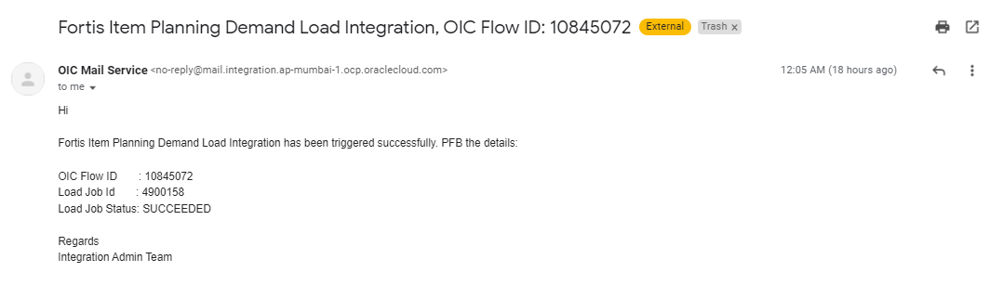

# Assumptions / Considerations

The Proposed Solution will have the following technical considerations.

In the future, if any product bug arises in functionality then this process needs to be revisited after the bug is fixed.

# Open and Closed Issues

## Open Issues

| ID | Issue | Resolution | Responsibility | Target Date | Impact Date |
| --- | --- | --- | --- | --- | --- |
|  |  |  |  |  |  |
|  |  |  |  |  |  |
|  |  |  |  |  |  |
|  |  |  |  |  |  |

## Closed Issues

| ID | Issue | Resolution | Responsibility | Target Date | Impact Date |
| --- | --- | --- | --- | --- | --- |
|  |  |  |  |  |  |
|  |  |  |  |  |  |
|  |  |  |  |  |  |
|  |  |  |  |  |  |